Validation is essential as it ensures data accuracy and data quality, and minimizes errors and ambiguity. It supports data integration and compliance with regulatory standards while facilitating effective decision-making by providing reliable insights. Overall, validation plays a crucial role in maintaining trustworthy data, therefore the following steps were taken to insure validity:

1. Coordinates are within the specified range: This validation step ensures that the latitude and longitude coordinates provided for each event fall within the geographic boundaries of Ukraine, which could indicate errors or inaccuracies in the dataset.
2. Dates fall within the specified range: This validation ensures that the dates associated with each event are within the defined range, ensuring that only valid and relevant events are included. All the events are in a specified timeframe, minimizing inconsistencies and maintaining the integrity of the dataset.
3. Events are plotted on a map to identify any occurrences outside Ukraine: visualizing the events on a map provides a clear overview of their geographic distribution. By checking if any events is plotted outside Ukraine, it helps detect and investigate any potential errors, outliers, or misclassified events that might have inadvertently been included in the dataset. Moreover, we perform an additional step to have all the events verified through an external API. This validation step ensures that the country attribute for all events is correctly set as Ukraine. By cross-referencing the country information using an external API, it provides an additional layer of verification to ensure that all events are associated with the correct country and align with the intended scope of the dataset.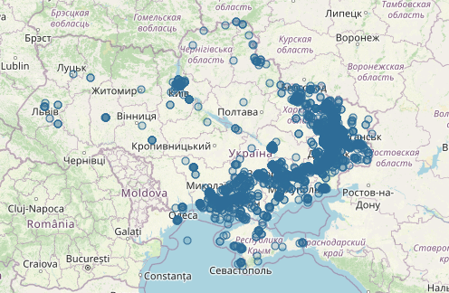
4. The data is syntactically valid to meet the requirements of the TriplyDB. This validation step ensures that the data adheres to these requirements. Successfully imported and stored in the TriplyDB without causing any issues or data integrity problems indicates that there is no syntactic error.
5. Information about cities is obtained from Geonames, a geographical database, using both the city name (string) and the associated coordinates. If the information retrieved using different methods (string and coordinates) differs, it may indicate discrepancies in the data or potential inconsistencies that need to be addressed.